Introduction to for problem statement.

* What is problem statement is?

A problem statement defines an issue or challenge that a project or initiative aims to address. It outlines the context, the scope of the problem, and the reasons why it is essential to find a solution. In the context of UML tools, a problem statement might articulate the shortcomings or difficulties users face with existing tools, providing a foundation for the development of a new or improved solution. It serves as a guiding document for understanding and solving a specific problem.

Scope of the project.

* Scope for the UML tools to represent models

Unified Modeling Language (UML) tools are software applications designed to facilitate the creation, visualization, and management of UML diagrams, which are graphical representations of various aspects of a software system. These tools play a crucial role in software engineering and system design by providing a standardized way to express and communicate complex concepts.

Project Title.

* Choosing problem statements and using data models to representing the solution: Utilizing different UML tools to represent models.

Problem statements related to UML tools.

**1. Lack of Standardization**: Many UML tools suffer from a lack of standardization, leading to compatibility issues between tools. Ensuring seamless interchangeability of UML diagrams across different tools is a persistent problem.

**2. Limited Collaboration Features:** Some UML tools may lack robust collaboration features, hindering effective teamwork among developers, analysts, and other stakeholders involved in the design process.

Addressing these challenges would enhance the effectiveness and user experience of UML tools in software engineering.

Scope for the UML tools to represent models.

**1. Requirements Analysis:** UML tools help in visually capturing and modeling system requirements through use case diagrams, activity diagrams, and class diagrams, facilitating better communication between stakeholders.

**2. Design Modeling:** UML tools support design modeling by creating class diagrams, sequence diagrams, state diagrams, and component diagrams. These models provide a blueprint for the system architecture, interactions, and component relationships.

Conclusion.

In short, employing diverse UML tools for modeling in software engineering enhances collaboration, streamlines design processes, and ensures consistency between design and implementation. The variety of tools available caters to specific modeling needs, contributing to an efficient and well-documented software development lifecycle.

Model name.

* Here for the represented project we are using “Waterfall Model”.

The Waterfall model is a linear software development approach that progresses through distinct phases—Requirements, Design, Implementation, Testing, Deployment, and Maintenance—in a sequential manner. Each phase must be completed before moving to the next, with minimal room for revisiting previous stages.

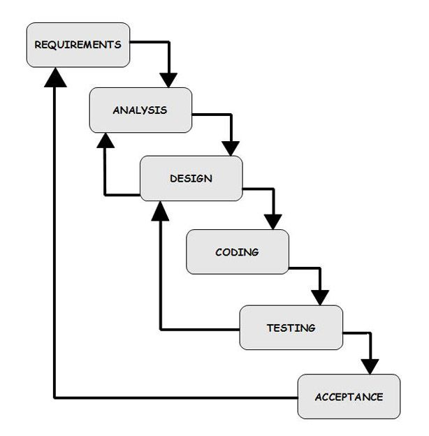

WORKING OF MODEL.

* In the context of using a UML tool within the Waterfall model in software engineering, here's a step-by-step guide:

In the Waterfall model:

**1. Requirements Phase:**

- Use UML tools to create use case and activity diagrams.

**2. Design Phase:**

- Develop class and sequence diagrams for system structure and dynamic interactions.

**3. Implementation Phase:**

- Generate code from UML diagrams and start coding.

**4. Testing Phase:**

- Derive test cases from UML diagrams and validate the system.

**5. Deployment Phase:**

- Create deployment diagrams and plan system distribution.

**6. Documentation:**

- Maintain and update UML diagrams as documentation.

**7. Collaboration:**

- Use UML tool collaboration features for team coordination.

**8. Integration with Project Management:**

- Align UML activities with project timelines.

**9. Review and Refinement:**

- Periodically review and refine UML representations.

**10. Finalization:**

- Complete UML documentation for future reference.

CONCLUSION.

In summary, incorporating UML tools into the Waterfall model provides a structured and visual approach for requirements clarification, system design, and documentation. While enhancing communication, it aligns well with the sequential nature of the Waterfall model. However, considerations for limited adaptability to changes should be noted.